IOT-BASED HOME AUTOMATION
A Smart Curtain System Based on IoT

By:
206040311039 - Datt N. Panchal
206040311041 - Nachiket V. Panara
206040311053 - Priyanshu S. Shah

Guided By:
Mr. Ketan S. Patel

A Project I Report Submitted to
Gujarat Technological University
in Partial Fulfilment of the Requirements for
the Certificate of Diploma of Engineering
in Electronics & Communication Engineering

December 2022
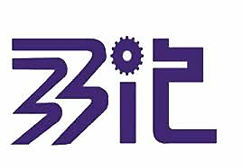
BHAILALBHAI AND BHIKHABHAI INSTITUTE OF TECHNOLOGY, V.V. NAGAR

CERTIFICATE

This is to certify that the project work embodied in this report entitled “IOT-BASED HOME AUTOMATION” was carried out by Mr. Datt N. Panchal (206040311039), Mr. Nachiket V. Panara (206040311041), and Mr. Priyanshu S. Shah (206040311053) at Bhailalbhai and Bhikhabhai Institute of Technology, V. V. Nagar for partial fulfilments of Diploma Engineering certificate to be awarded by Gujarat Technological University. This project work has been carried out under my supervision and is to my satisfaction.

Date: 12/11/2022
Place: Vallabh Vidyanagar, Anand

Signature and Name of Supervisor (s) Signature and Name of H.O.D.

Seal of Institute

ACKNOWLEDGEMENT

For now, we only wish to simply acknowledge Mr. Ketan S. Patel, who helps us during this entire project.

TABLE OF CONTENTS

Contents | Page no.
Title Page | 1
Certificate Page | 2
Acknowledgment | 3
List of Chapters | 6
List of Figures | 7
List of Tables | 8
Chapter 1: Introduction | 9
Chapter 2: Block Diagram | 12
Chapter 3: Circuit Diagram | 14
Chapter 4: Electronics components (hardware), software, and applications | 17
Chapter 5: Advantages, Disadvantages, and Applications | 29
References | 30
Appendix-1: Programming (Project Code) | 31
Conclusion | 32
Weekly Report | 33

LIST OF CHAPTERS

Chapter No. | Page No.
Chapter 1: Introduction | 9
Chapter 2: Block Diagram of Project | 13
Chapter 3: Circuit Diagram of Project | 15
Chapter 4: Major and Minor Electronics Components | 18
Chapter 5: Advantages, Disadvantages | 27

LIST OF FIGURES

Figures | Page No.
Figure 2.1 Block Diagram of project.
Figure 3.1 Circuit Diagram of project.
Figure 4.1 NodeMCU
Figure 4.2 pin diagram of NodeMCU
Figure 4.3 2- channel relay module
Figure 4.4 Motor
Figure 4.5 SMPS
Figure 4.6 Limit Switch
Figure 4.7 Arduino IDE
Figure 4.8 Blynk
Figure 4.9 Multisim Live
Figure 4.10 Altium Designer

LIST OF TABLES

Tables | Page No.
Table 3.1 Pin connection between NodeMCU & Relay
Table 3.2 Input And Output
Table 3.3 Input & Output
Table 4.1 Specification of NodeMCU board

CHAPTER 1: INTRODUCTION

- What Is the Internet of Things (IoT)?
The Internet of Things, or IoT, is a system of interactive devices, machines, objects, or Nigerians that share data for a network without humans. Human or interpersonal relationships.

What is on the Internet can be a person who has the heart to check it, a pet with a movement that repeats it every time. Something that can be assigned an Internet Protocol (IP) address and can transfer data over a network. Increasingly, organizations and companies are using IoT to better understand customers better, provide better customer service, and make decisions that increase market value.

- Why IoT is Important?
The Internet of Things helps people live and work better, and take better control of their lives. In addition to providing smart devices to perform household tasks, IoT is important for businesses. The IoT gives businesses real-time insight into how their systems are working, providing insight into everything from machine performance to installation and logistics operations.

IoT allows companies to automate processes and reduce costs. It reduces waste, improves service delivery, makes producing and delivering goods cheaper, and provides insight into customer transactions.

As such, IoT is one of the most important technologies in everyday life, and it will continue to gain momentum as more businesses realize the potential of connected devices to remain competitive.

- What are the benefits of IoT?
The Internet of Things offers a variety of benefits. Some benefits are company specific; some apply to many companies. Some of the important benefits of IoT to help businesses:

- Review their overall business process;
- Improve customer experience (cx);
- Save time and money;
- Improve employee productivity;
- Integrating and adapting business models;
- Make better business decisions; and
- Increases their income.

IoT encourages companies to rethink the way they do business and gives them the tools to improve their business strategy. Typically, IoT is prevalent in manufacturing, transportation, and utility industries, using sensors and other IoT devices; however, it has identified use cases for organizations in agriculture, utilities, and home automation industries, leading some organizations to digital transformation.

IoT can help farmers in farming by making it easier for them. The sensor can collect data on rainfall, humidity, temperature, and soil content, among other factors, which will help develop agricultural systems.

Home automation companies can use IoT to monitor and control home mechanical and electrical systems. On a larger scale, smart cities can help citizens reduce their waste and energy consumption. IoT affects every industry, including business, healthcare, finance, commerce, and manufacturing.

- What are the pros and cons of IoT?

Some of the benefits of IoT are:

- The ability to access information from any place, any time, and any device
- Better communication between connected electronic devices
- Transfer data packets over connected networks saving time and money and
- Streamline operations that help improve the quality of the company's operations and reduce the need for human resources.

Some of the disadvantages of IoT include the following:

- As the number of connected devices increases and more information is shared between devices, the risk of a hacker being able to steal confidential information increases.
- Companies may end up managing a large number – perhaps even millions – of IoT devices, and collecting and managing data from all those devices will be a challenge.
- If there is a bug in the system, chances are that all connected devices will be damaged.
- Since there is no international interoperability standard for IoT, it is difficult for devices from different manufacturers to communicate with each other.

- What is Home Automation?
"Home automation" refers to the automatic and electronic control of home functions, services, and appliances. Simply put, it means that you can easily manage the appliances and features of your home through the Internet to make life easier and safer and even spend less money on rent. Read on to find answers to some frequently asked

questions about home automation technology and get some ideas for home automation solutions to add to your home.
- How Does Home Automation Works?
Home automation is a network of hardware, communications, and electronics that work to connect everyday devices through the Internet. Each device has a sensor and is connected via WIFI, so you can control them with your smartphone or tablet, whether you are at home or miles away. This allows you to turn on the light, lock the door or even turn off the light, wherever you are.

There are three main components in a home automation system:
- Sensors, controls, and actuators. Sensors can monitor changes in daylight, temperature, or motion detection. A home automation system can configure these settings (and others) to your liking.

- Controllers refer to devices - personal computers, tablets, or smartphones - used to send and receive information about the status of automation in your home.

- Actuators can be light switches, motors, or motorized valves that control the process or function of the home automation system. They are designed to work through remote commands from the controller.

- What features are available through home automation systems?
Home automation systems offer a variety of services and functions. Some of the more common features available through these platforms include:
• Fire and carbon monoxide monitoring
• Remote lighting control
• Thermostat control
• Appliance control
• Home automation security systems and cameras
• Live video surveillance
• Alarm systems
• Real-time text and email alerts
• Digital personal assistant integration
• Keyless entry
• Voice-activated control

- What are the benefits of Home Automation?
The purpose of a home automation system is to streamline how your home functions. Consider some of these benefits:
• Remote access: Control your home from mobile devices, including your laptop, tablet, or smartphone.
• Comfort: Use home automation to make your home a more comfortable, liveable space. Preprogramme your thermostat with your preferred settings so that your home is always at a comfortable temperature, set up smart speakers to play music when you get home from work, or adjust your lights to soften or brighten based on the time of day.
• Convenience: Program devices to turn on automatically at certain times, or access their settings remotely from anywhere with an Internet connection. When you don’t have to remember to lock the door behind you or switch off the lights, you can turn your attention to more important things.
• Increased safety: Smart fire detectors, carbon monoxide monitors, pressure sensors, and other home automation security features can help protect your home from disaster.
• Energy efficiency: Home automation allows you to be more mindful of your power usage. For example, you can save on energy bills by reducing the time that lights stay on or lowering temperatures when you leave a room.

CHAPTER 2: BLOCK DIAGRAM

The block diagram of the project is shown below:
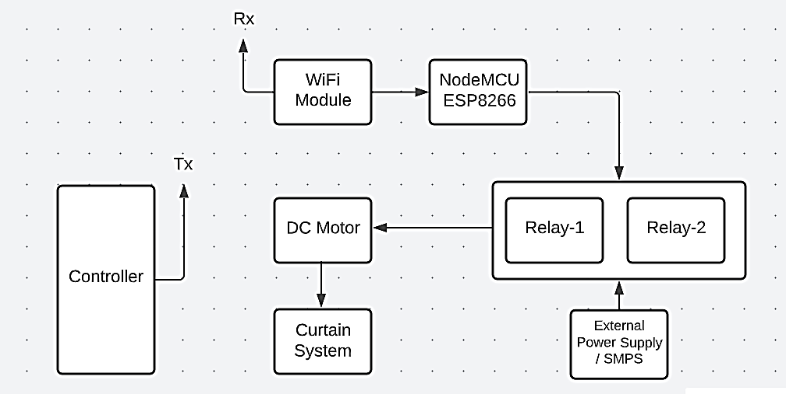

The above block diagram shows the system of IoT-Based Home Automation where we can control our home appliances easily with the help of WIFI or any other type of network like Bluetooth. Now, let’s see the function of each block given in the block diagram.

Controller
The controller is the main device of this system. Without a controller, we could not say it IoT based. This controller may be your Mobile Phone, PC-Laptop, Remote, etc. Using this controller, we can control our home appliances from anywhere in the home, you can control your house devices easily with this controller.
A controller is connected to one particular network. Here, the network is made using WIFI. We have to connect this controller to our WIFI device (NodeMCU ESP8266) using WIFI. This controller sends the data you give to the NodeMCU ESP8266 WIFI Module. Here data means the commands you give to the system like LED ON or LED OFF.
The controller transmits this data and our NodeMCU ESP8266 receives this data with the help of the WIFI Network we make. According to the commands we give the system works and behaves.

WIFI Module
The WIFI Module receives the command (data) using the WIFI Network. And then when it receives the data it gives it to the NodeMCU ESP8266 Module.
NodeMCU ESP8266
The input data of the NodeMCU ESP8266 comes from the inbuilt WIFI Module. The NodeMCU ESP8266 is programmed here. It is programmed by the programmer. We have to upload that program into the NodeMCU ESP8266 WIFI Module. According to the program and data, this module controls the entire system.
Relays
With the NodeMCU ESP8266, we connect the relays. A relay is an electromechanical switch that has three output terminals. Common, Normally Open, and Normally Close. We will see these components briefly in the next chapters.
The NodeMCU ESP8266 gives the commands to the relay. The relay accepts only two data in form of 0 and 1. When 0 comes, the relay is in the OFF state and when 1 comes the relay is in the ON state.
Home Appliances
And with this relay, we connected our home appliances/devices (Here, we connected Curtain). And according to the state (0 or 1) of the relay, the connected devices work.

CHAPTER 3: CIRCUIT DIAGRAM

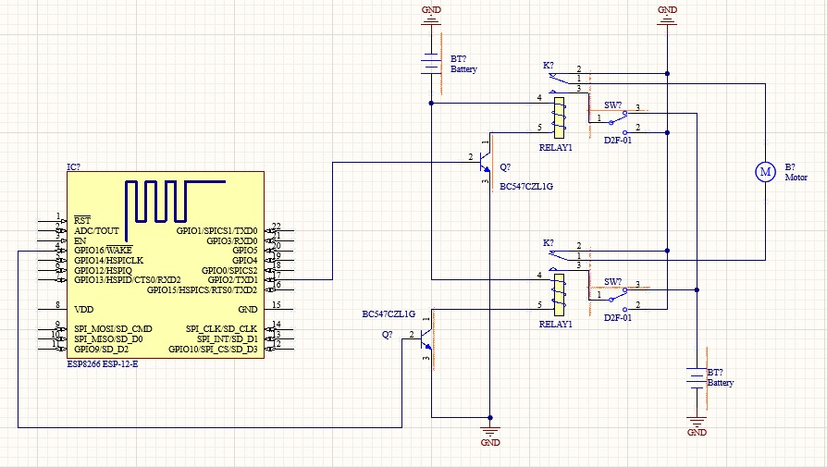
The circuit diagram of the project is shown below:

The above circuit diagram shows the circuitry of our project. Now, let’s see how this circuit works!
As you can see in the circuit diagram, the NodeMCU ESP8266 is connected. Here, we cannot find the exact module of the ESP8266, but the pins we required are given in this module. So, for understanding, we connected that module here.
Here, we connected the two relays with ESP8266. The connection between Relays and ESP8266 is shown in the table below:

Pins of ESP8266 Module | Pins of Relay 1 & 2
GPIO-16 | Positive of Relay 1
GPIO-2 | Positive of Relay 2
GND | Both GND of Relays

With two relays, we connected one DC Motor here because we had to move the curtain from one side to another. The connection between the two relays and DC Motor is shown below table:

Relay-1 | External | DC Motor
Common |  | Positive of Motor
Normally Open | +VCC | -
Normally Close | GND | -

Relay-2 | External | DC Motor
Common |  | Negative of Motor
Normally Open | +VCC | -
Normally Close | GND | -

The logic behind the working of the circuit

Case 1
When Relay-1 is in the OFF state and Relay-2 is in the ON state, the DC Motor will be OFF. Because when both Relays are OFF, then both GND pins of both relays are connected to the DC Motor so no supply will be connected to the Motor. So, in this case, the DC Motor will be in an OFF state.
Case 2
When Relay-1 is in the ON state and Relay-2 is in the OFF state, the DC Motor will be ON. Because the common terminal of Relay-1 is connected with Normally Open. But, here Normally open terminal of Relay-1 is connected with +VCC. And the GND is provided by the relay-2 to the Motor. So, at the positive terminal of the DC Motor, the VCC will connect, and negative terminal of the DC Motor, the ground will connect. In this case, the DC Motor will be ON.
Case 3
When Relay-1 is in the OFF state and Relay-2 is in the ON state, the DC Motor will be OFF. Because the common terminal of Relay-2 is connected with Normally Open. But, here Normally open terminal of Relay-2 is connected with +VCC. And the GND is provided by the relay-1 to the Motor. So, at the positive terminal of the DC Motor, the ground will connect, and negative terminal of the DC Motor, the VCC will connect. In this case, the DC Motor will be OFF.
Case 4
When both Relays is ON, both common terminal of both relays will connect to the Normally Open terminals so, at both terminals of the DC Motor, the VCC will connect. So, in this case, the DC Motor will be OFF.

This is how the circuit works. You can easily clear this logic by seeing the below table:

Relay-1 | Relay-2 | DC Motor
OFF | OFF | OFF
ON | OFF | ON
OFF | ON | OFF
ON | ON | OFF

So, this is all about the circuit!

CHAPTER 4: ELECTRONICS COMPONENTS (HARDWARE) & SOFTWARE

Software will have a place in the electronics industry, where software is worthless without the hardware to run it. In addition, there is currently no universal black box that can meet all product requirements.
Electronics are an important part of the manufacturing process of electronics. The quality of the equipment used in the production process can quickly determine your future and growth in the industry. Quality components ultimately improve the quality of the end product and its durability.
The list of hardware, software, and application that we used to complete this project is given below. The software used here is completely free, you can also use it in your application.

List of Electronic Components (Hardware)
- ESP8266 NodeMCU with Inbuilt WIFI module
- 5V Relay Module
- DC Motor
- SMPS (24V DC, 1A)
- General Purpose Printed Circuit Board (PCB)
- Wires
- Limit Switch
- 5V Battery, etc.

List of Software and Application (Offline & Online)
- Arduino Integrated Development Environment / Arduino IDE
- Blynk IoT Application (Web-Based & Android-Based Application)
- Multisim Live Online Simulator (Web-Based)
- Altium Designer

ESP8266 NodeMCU
- ESP8266 is a wife SOC (system on a chip). It is a highly integrated chip designed to provide full internet connectivity in a small package.
- ESP8266 is a low-cost wife microcontroller with a full TCP/IP stack. It has many GPIO (general purpose input output pins) for interfacing with different sensors.
- ESP8266 due to its low cost and good functionality is used a lot in prototyping IoT products.
- Its cross-functionality with Arduino makes it easy to program with Arduino IDE.
- The ESP8266 module enables microcontrollers to connect to 2.4 GHz Wi-Fi. It can be used with ESP-AT firmware to provide Wi-Fi connectivity to external host MCUs, or it can be used as a self-sufficient MCU by running an RTOS-based SDK. The module has a full TCP/IP stack and provides the ability for data processing, reads, and controls of GPIOs.

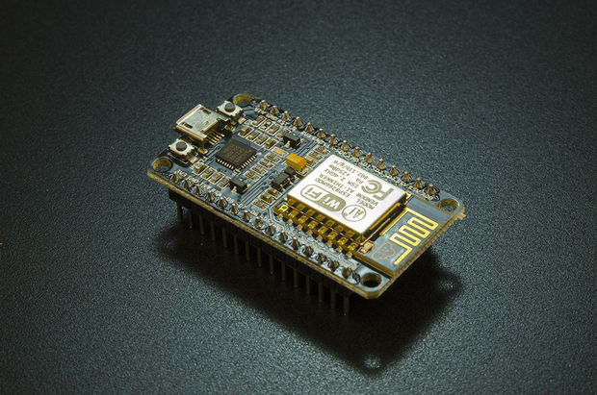

Specifications of ESP8266
ESP8266 Parameters | Description
Core | 1
Architecture | 32-bit
Typical Frequency | 80 MHz
Bluetooth | No
RAM | 160KB
GPIO Pins | 16
DAC | 0
ADC | 1 (10-bit)

Pin Diagram of ESP8266

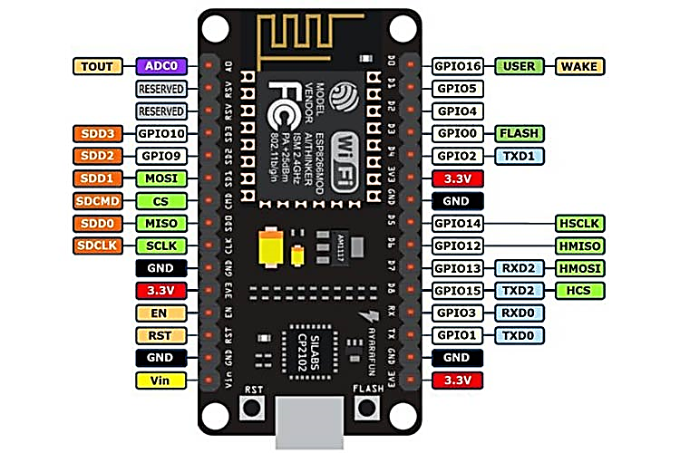

Advantage of ESP8266 over other competitors like Arduino
The main advantage is the built-in wireless technology that is user-friendly without the use of shields or externals, as required for Arduinos. Price and size are the USPs of the module with the added benefit of good speed and processing power. Arduinos are about 10 times more expensive and larger than ESPs with comparable processing power.

Disadvantages of ESP8266
- Memory limit.
- Power is low.
- The processing power is lower than the microcontroller.
- Requires effort to complete certain tasks such as database management and security.

Applications of ESP8266
- Smart security devices, including surveillance cameras and smart locks.
- Smart energy devices include HVAC and thermostats. Intelligent industrial equipment, including programmable logic controllers (PLCs)
- Smart health devices, including wearable health monitors.

5V 2-Channel Relay Module

- 2-Channel 5V Relay Module is a relay interface board, it can be controlled directly by a wide range of microcontrollers such as Arduino, AVR, PIC, ARM, and so on. It uses a low-level triggered control signal (3.3-5VDC) to control the relay. Triggering the relay operates the normally open or normally closed contacts.
- It is frequently used in an automatic control circuit. To put it simply, it is an automatic switch to control a high-current circuit with a low-current signal.5V relay signal input voltage range, 0-5V. VCC power to the system. JD-VCC relay in the power supply. JD-VCC and VCC can be shorted.
Pin Configuration of 2-Channel Relay Module
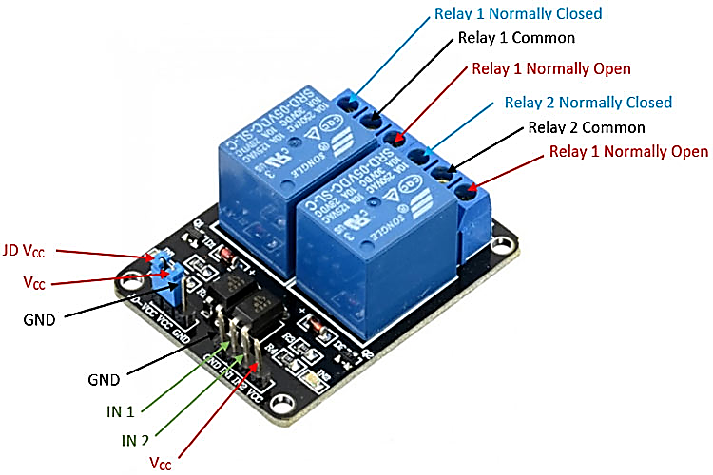

Features of the 2-Channel Relay Module
- Good for safe control of higher amperage circuits. In power systems, the lower current can control the higher one.
- 2-channel high voltage system output, meeting the needs of dual-channel control.
- Brand new and high quality.
- Standard interface that can be controlled directly by microcontroller (Arduino, 8051, AVR, PIC, DSP, ARM)]
- Wide range of controllable voltages.
- Being able to control high load current, which can reach 250V, 10A or 125V, 15A
- With a normally open (NO) contact and a normally closed (NC) contact.
- Around the board with 4 mounting holes, easy installation, and fixing
- It has a common end, a beginning, a closed-end
Specifications of the 2-Channel Relay Module
- Relay Module; Model: JQC-3FF-S-Z, 2 Channel
- Voltage to operate: 5V D
- Colour: Blue Relays on a black PCB
- Load: 10A, AC 250V/ 15A, 125V

24V DC Motor
- A DC motor is defined as a class of electrical motors that convert direct current electrical energy into mechanical energy.
- When kept in a magnetic field, a current-carrying conductor gains torque and develops a tendency to move. In short, when electric fields and magnetic fields interact, a mechanical force arises. This is the principle on which the DC motors work.



24V & 5V Switched Mode Power Supply
A switching power supply (SMPS) is an electronic circuit that converts power using a switching device that is turned on and off at a high frequency, and a storage device such as an inductor or capacitor to provide power when the switching device is not available.
Power switches are very efficient and are used in many different electronic devices, including computers and other sensitive devices that require stable and efficient power. A variable flame is also called a flame or a flame.
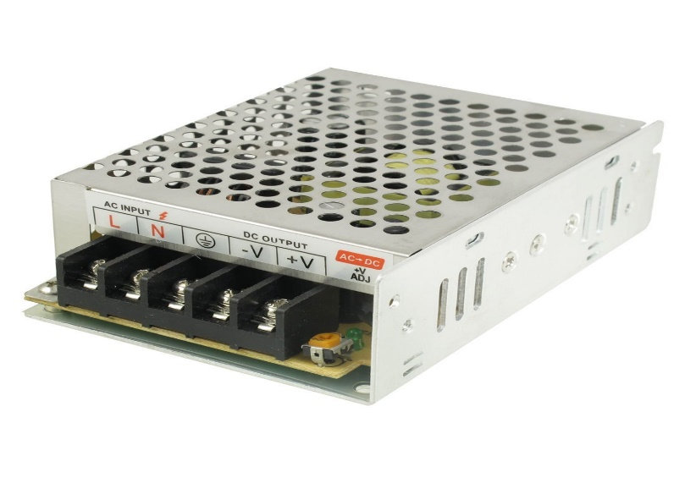
Limit Switch ( Plunger )
A limit switch is an electronic device in which a physical force is applied to an object. A limit switch is used to determine the presence or absence of an object. These switches are used to set the limit of movement of objects, so they are called Limit Switches.

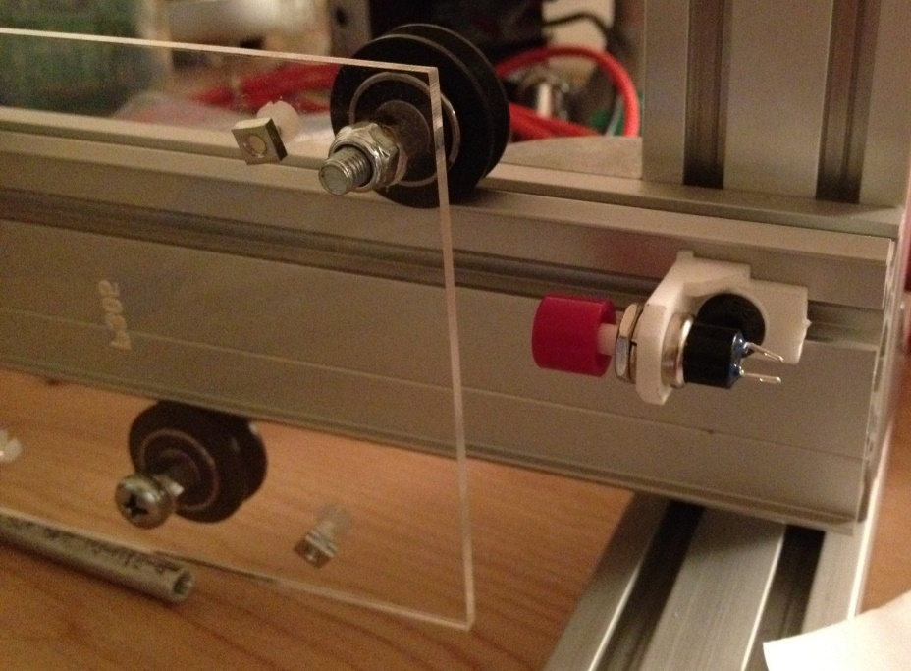

Arduino Integrated Development Environment / Arduino IDE
- The Arduino Integrated Development Environment - or Arduino Software (IDE) - contains a text editor for writing code, a message area, a text console, a toolbar with buttons for common functions, and a series of menus. It connects to the Arduino hardware to upload programs and communicate with them.

- The open-source Arduino Software (IDE) makes it easy to write code and upload it to the board. This software can be used with any Arduino board.

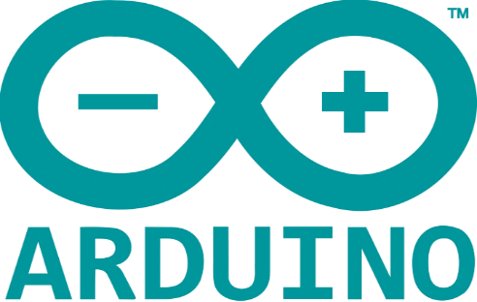

Blynk IoT Platform
- Blynk is an IoT platform for iOS or Android smartphones used to control Arduino, Raspberry Pi, and NodeMCU over the Internet. This tool makes it possible to create a graphic or human interface (HMI) by collecting and assigning the appropriate address to the available widgets. Blynk is built for the Internet of Things. It can control hardware remotely, it can display data from sensors, can store data, visualize it, and do many other cool things.
- It is available for both web-based and android-based.

There are three main features of the platform:
- Blynk Tool: - It allows you to create an amazing interface for your work using the various widgets provided.
- Blynk Server: - It is responsible for communication between smartphones and hardware. You can use Blynk Cloud or run your Blynk server locally. It's open source, can easily manage thousands of devices, and can be run on a Raspberry Pi.
- Blynk Library: - It enables communication, for all popular hardware platforms, servers, and all immigration rules.



Multisim Live Online Simulator
- Multisim Live is a web-based electronic schematic capture and simulation tool with built-in SPICE-based simulation. With Multisim Live, design and simulation will be available anywhere: at school, at work, at a coffee shop, and even on mobile devices.

Features of Multisim Live Online Simulator

Expanding the Multisim Experience

Create Circuit Schematics on any platform

Interactive Circuit Simulation with No Installation

Same Industry-Standard SPICE Simulation

Share Your Circuit Brilliance

Complete Circuits Teaching Solution

New Features All the Time

Stream Circuit Simulation from Multisim Live to Measurements Live

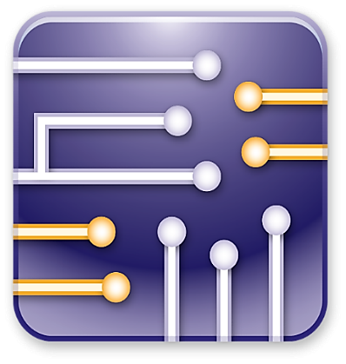

Altium Designer
- Altium Designer is one of the most popular high-end PCB design software packages on the market today. It is developed and marketed by Altium Limited. Including a schematic, PCB module, and an auto-router and differential pair routing features, it supports track length tuning and 3D modelling.

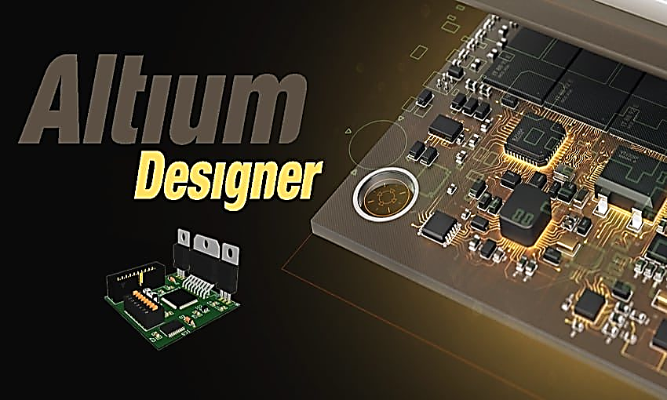

CHAPTER 5: ADVANTAGES, DISADVANTAGES & APPLICATIONS

Advantages of Smart Home Automation
- Convenience
- Better Home Management
- Complete Control
Disadvantages of Smart Home Automation
- Security Issues
- Cost: Extremely expensive
- Maintenance
Applications of Smart Home Automation
- Lighting control
- Household electronic Appliances
- AI-driven digital experiences

REFERENCES

- To know more about NodeMCU ESP8266
- To learn to program NodeMCU on Arduino IDE
- To learn more about Relay
- To learn to control ESP8266 with the Blynk Cloud Application
- Setting up the Blynk with ESP8266
- Download the Blynk IoT Android Application
- Guide to setup and program the NodeMCU ESP8266
- Learn to connect ESP8266 with Blynk ( Web-Based and App-Based )
- Complete Guide to do IoT-Based Home Automation with Blynk
- IoT Home Automation using ESP8266 with Blynk
- Understood IoT, Hardware, and software we need
- Setup and Programming
- Learned about Blynk

APPENDIX-1: PROGRAMMING (PROJECT CODE)

// Include the library files of Blynk and ESP8266 Module
#include <ESP8266WiFi.h>
#include <BlynkSimpleEsp8266.h>
#define BLYNK_PRINT Serial

// Authentication token to connect Blynk with ESP8266 Wi-Fi Module
#define BLYNK_AUTH_TOKEN "BvnfLko3cIa1B7DSJMBxer2hh3MZXuHO"

char auth[] = BLYNK_AUTH_TOKEN;
char ssid[] = "Nachiket"; // SSID of Wi-Fi Network
char pass[] = "notchu@3"; // Password of Wi-Fi Network

// Function to process the data which are coming from the Blynk application
BLYNK_WRITE(V0) {
if(param.asInt()==0){
digitalWrite(D4, LOW);
digitalWrite(D0, HIGH);
}
else{
digitalWrite(D4, HIGH);
digitalWrite(D0, LOW);
}
}

void setup() {
// Set the D4 and D0 pin as a output pins
pinMode(D4, OUTPUT);
pinMode(D0, OUTPUT);

Blynk.begin(auth, ssid, pass, "blynk.cloud", 80);
}

void loop() {
Blynk.run();
}

CONCLUSION
By doing this project we learn about various aspects of electronics. We learn how to make a circuit. This made us learn the analog aspect of our project. We program the microcontroller. This was the embedded aspect. We used ESP 8266 Wi-Fi chip to control the motor. That was the network side of our project & we assembled this project with a mechanical structure, this thing made us learn the mechanical side also.
We also came up with some new ideas and we are going to apply that idea to our project in the next term of our project.

